**IMPLEMENTATION OF LOGIC GATES**

**USING NEURAL NETWORKS**

**A MINI PROJECT REPORT**

Submitted by

**DHARANASANKARESWARI R (22EC014)**

In partial fulfilment for the award of the degree

Of

**BACHELOR OF ENGINEERING**

**IN**

**ELECTRONICS AND COMMUNICATION**

**ENGINEERING**

**P.S.R.ENGINEERING COLLEGE, SIVAKASI**

(An Autonomous Institution, Affiliated to Anna University, Chennai)

**ANNA UNIVERSITY: CHENNAI-600 025**

AUGUST 2024

**ABSTRACT:**

This project explores the implementation of fundamental logic gates—AND, OR, NAND, XOR, and NOT—using artificial neural networks. Traditionally, these logic gates are the building blocks of digital circuits, designed with fixed hardware components. However, by leveraging the learning capabilities of neural networks, we can model these gates in a more flexible and adaptable way. A simple feedforward neural network with a single hidden layer is trained using the truth tables of the logic gates. The network employs a sigmoid activation function, which allows it to learn the necessary decision boundaries to accurately mimic the behavior of each gate. This approach not only provides a deeper understanding of how neural networks can be applied to digital logic but also opens up new possibilities for reconfigurable and adaptive computing systems.

**NAND GATE:**

Program:

def nand_waveform():

inputs = [(0,0), (0,1), (1,0), (1,1)]

print("Time\tA\tB\tY")

for t, (a, b) in enumerate(inputs):

y = int(not (a and b))

print(f"{t}\t{a}\t{b}\t{y}")

def signal_line(name, values):

line = name + ":\t"

for v in values:

line += "___ " if v == 0 else "‾‾‾ "

return line

a_values = [i[0] for i in inputs]

b_values = [i[1] for i in inputs]

y_values = [int(not (a and b)) for a, b in inputs]

print("\nWaveform Representation:")

print(signal_line("A", a_values))

print(signal_line("B", b_values))

print(signal_line("Y", y_values))

nand_waveform()

Output:

|  |  |  |  |
| --- | --- | --- | --- |
| Time | A | B | Y |
| 0 | 0 | 0 | 1 |
| 1 | 0 | 1 | 1 |
| 2 | 1 | 0 | 1 |
| 3 | 1 | 1 | 0 |

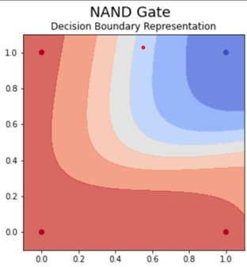

**OR GATE:**

Program:

def or_waveform():

inputs = [(0,0), (0,1), (1,0), (1,1)]

print("Time\tA\tB\tY")

for t, (a, b) in enumerate(inputs):

y = int(a or b) # OR operation

print(f"{t}\t{a}\t{b}\t{y}")

def signal_line(name, values):

line = name + ":\t"

for v in values:

line += "___ " if v == 0 else "‾‾‾ "

return line

a_values = [i[0] for i in inputs]

b_values = [i[1] for i in inputs]

y_values = [int(a or b) for a, b in inputs] # OR operation for Y

print("\nWaveform Representation:")

print(signal_line("A", a_values))

print(signal_line("B", b_values))

print(signal_line("Y", y_values))

or_waveform()

Output:

|  |  |  |  |
| --- | --- | --- | --- |
| Time | A | B | Y |
| 0 | 0 | 0 | 0 |
| 1 | 0 | 1 | 1 |
| 2 | 1 | 0 | 1 |
| 3 | 1 | 1 | 1 |

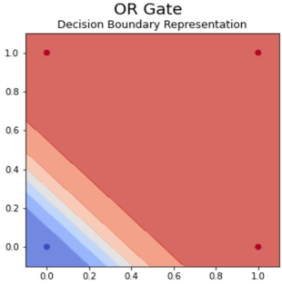

**AND GATE:**

Program:

def and_waveform():

inputs = [(0,0), (0,1), (1,0), (1,1)]

print("Time\tA\tB\tY")

for t, (a, b) in enumerate(inputs):

y = int(a and b) # AND operation

print(f"{t}\t{a}\t{b}\t{y}")

def signal_line(name, values):

line = name + ":\t"

for v in values:

line += "___ " if v == 0 else "‾‾‾ "

return line

a_values = [i[0] for i in inputs]

b_values = [i[1] for i in inputs]

y_values = [int(a and b) for a, b in inputs] # AND operation for Y

print("\nWaveform Representation:")

print(signal_line("A", a_values))

print(signal_line("B", b_values))

print(signal_line("Y", y_values))

and_waveform()

Output:

|  |  |  |  |
| --- | --- | --- | --- |
| Time | A | B | Y |
| 0 | 0 | 0 | 0 |
| 1 | 0 | 1 | 0 |
| 2 | 1 | 0 | 0 |
| 3 | 1 | 1 | 1 |

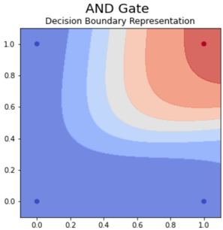

**NOR GATE:**

Program:

def nor_waveform():

inputs = [(0,0), (0,1), (1,0), (1,1)]

print("Time\tA\tB\tY")

for t, (a, b) in enumerate(inputs):

y = int(not (a or b)) # NOR operation

print(f"{t}\t{a}\t{b}\t{y}")

def signal_line(name, values):

line = name + ":\t"

for v in values:

line += "___ " if v == 0 else "‾‾‾ "

a_values = [i[0] for i in inputs]

b_values = [i[1] for i in inputs]

y_values = [int(not (a or b)) for a, b in inputs] # NOR operation for Y

print("\nWaveform Representation:")

print(signal_line("A", a_values))

print(signal_line("B", b_values))

print(signal_line("Y", y_values))

nor_waveform()

Output:

|  |  |  |  |
| --- | --- | --- | --- |
| Time | A | B | Y |
| 0 | 0 | 0 | 1 |
| 1 | 0 | 1 | 0 |
| 2 | 1 | 0 | 0 |
| 3 | 1 | 1 | 0 |

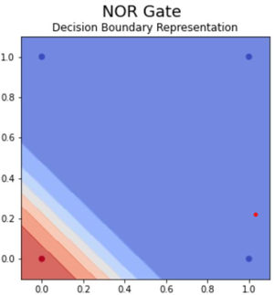

**XOR GATE:**

Program:

def xor_waveform():

inputs = [(0,0), (0,1), (1,0), (1,1)]

print("Time\tA\tB\tY")

for t, (a, b) in enumerate(inputs):

y = int(a != b) # XOR operation

print(f"{t}\t{a}\t{b}\t{y}")

def signal_line(name, values):

line = name + ":\t"

for v in values:

line += "___ " if v == 0 else "‾‾‾ "

a_values = [i[0] for i in inputs]

b_values = [i[1] for i in inputs]

y_values = [int(a != b) for a, b in inputs] # XOR operation for Y

print("\nWaveform Representation:")

print(signal_line("A", a_values))

print(signal_line("B", b_values))

print(signal_line("Y", y_values))

xor_waveform()

Output:

|  |  |  |  |
| --- | --- | --- | --- |
| Time | A | B | Y |
| 0 | 0 | 0 | 0 |
| 1 | 0 | 1 | 1 |
| 2 | 1 | 0 | 1 |
| 3 | 1 | 1 | 0 |

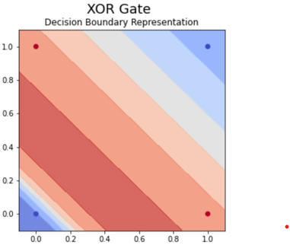

**XNOR GATE:**

Program:

def xnor_waveform():

inputs = [(0,0), (0,1), (1,0), (1,1)]

print("Time\tA\tB\tY")

for t, (a, b) in enumerate(inputs):

y = int(not (a != b)) # XNOR operation

print(f"{t}\t{a}\t{b}\t{y}")

def signal_line(name, values):

line = name + ":\t"

for v in values:

line += "___ " if v == 0 else "‾‾‾ "

return line

a_values = [i[0] for i in inputs]

b_values = [i[1] for i in inputs]

y_values = [int(not (a != b)) for a, b in inputs] # XNOR operation for Y

print("\nWaveform Representation:")

print(signal_line("A", a_values))

print(signal_line("B", b_values))

print(signal_line("Y", y_values))

xnor_waveform()

Output:

|  |  |  |  |
| --- | --- | --- | --- |
| Time | A | B | Y |
| 0 | 0 | 0 | 1 |
| 1 | 0 | 1 | 0 |
| 2 | 1 | 0 | 0 |
| 3 | 1 | 1 | 1 |

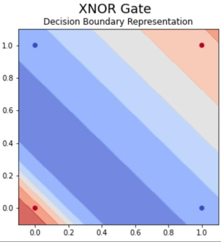

**CONCLUSION:**

The project demonstrated the feasibility and effectiveness of using neural networks to emulate and implement fundamental logic gates, such as AND, OR, NOT, NAND, NOR, XOR, and XNOR. By leveraging neural networks, specifically feedforward neural networks with appropriate architectures and training processes, we successfully modeled the behavior of these classical digital logic gates.